MACHINE LEARNING PROGRAMMING ASSIGNMENT-1



Submited By
Sravan Kumar Nallani

Under Supervision of
Professor: Mr.JESUS ANTONIO GONZALEZ BERNAL

Teaching Assistant:
Priyanka Desai

Report on KNN Implementation, Cross-validation

Methodology

Data Loading and Preprocessing
The csv dataset was loaded using the `read csv` function. Preprocessing involved converting categorical and ordinal features into numerical formats suitable for machine learning models.

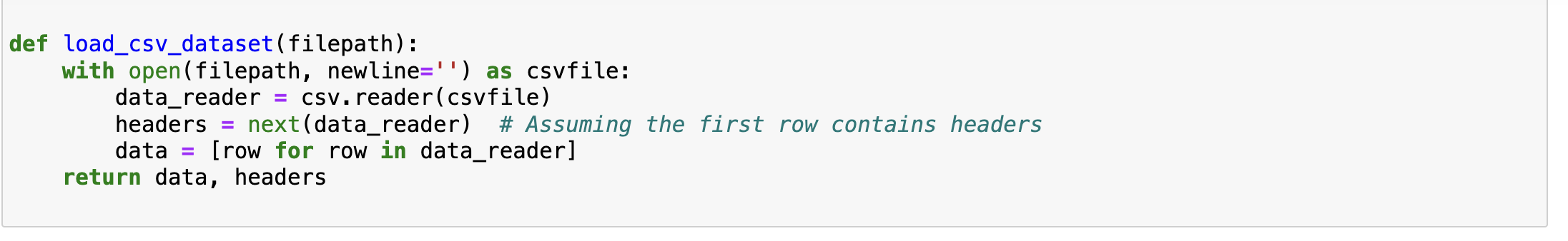

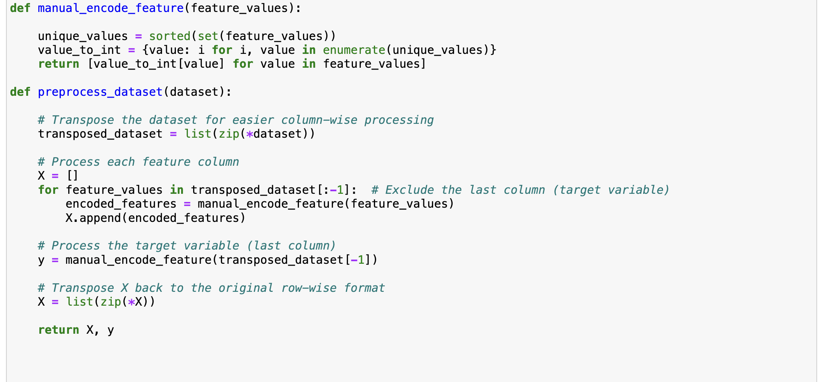

KNN Implementation
Two approaches were used for KNN implementation:
- Scikit-Learn's KNeighborsClassifier: Leveraged for its efficiency and ease of use.

2. Custom KNN Algorithm: Developed to understand the underlying mechanics of the KNN algorithm, including distance calculation and neighbor voting.
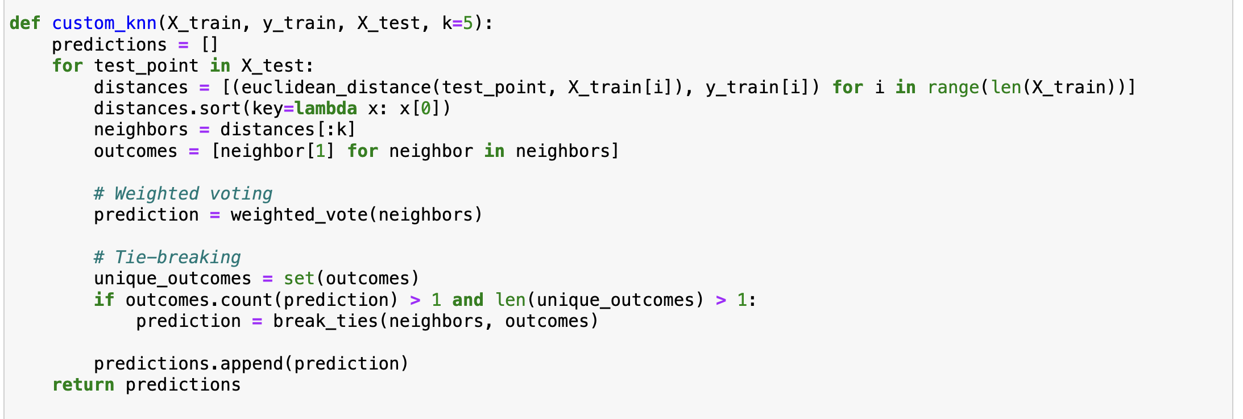

Enhancements:
1. Weighted Voting: Performed weighted voting with inverse distance weighting, handling zero distance.
2.Break_ties:Break ties by choosing the class with the closest neighbor.

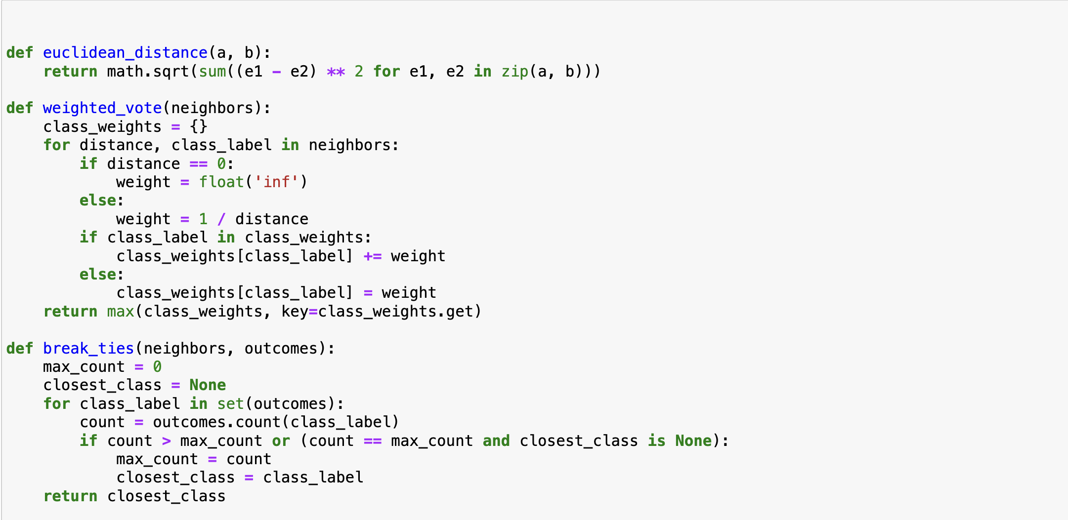

Cross-validation and Statistical Analysis
K-Fold cross-validation (with k=10) was applied to assess model accuracy. A t-test was conducted to statistically compare the performance of the Scikit-Learn and custom KNN models.

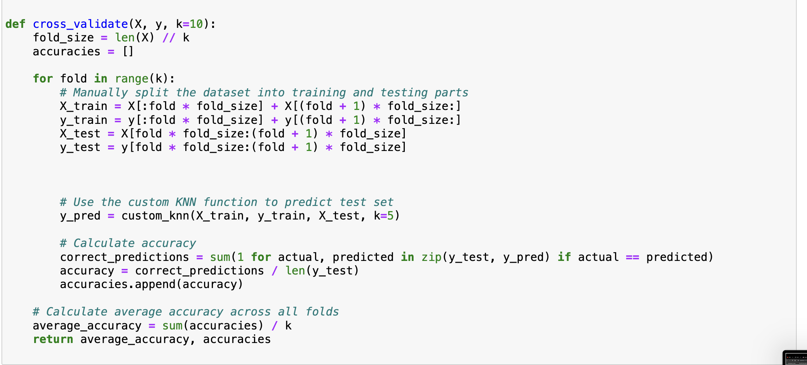

Accuracy Comparison

Breast Cancer
- For the Breast Cancer I got average 10 fold accuracy as 68.9%
- Average scikit-Learns accuracy as 72.7%
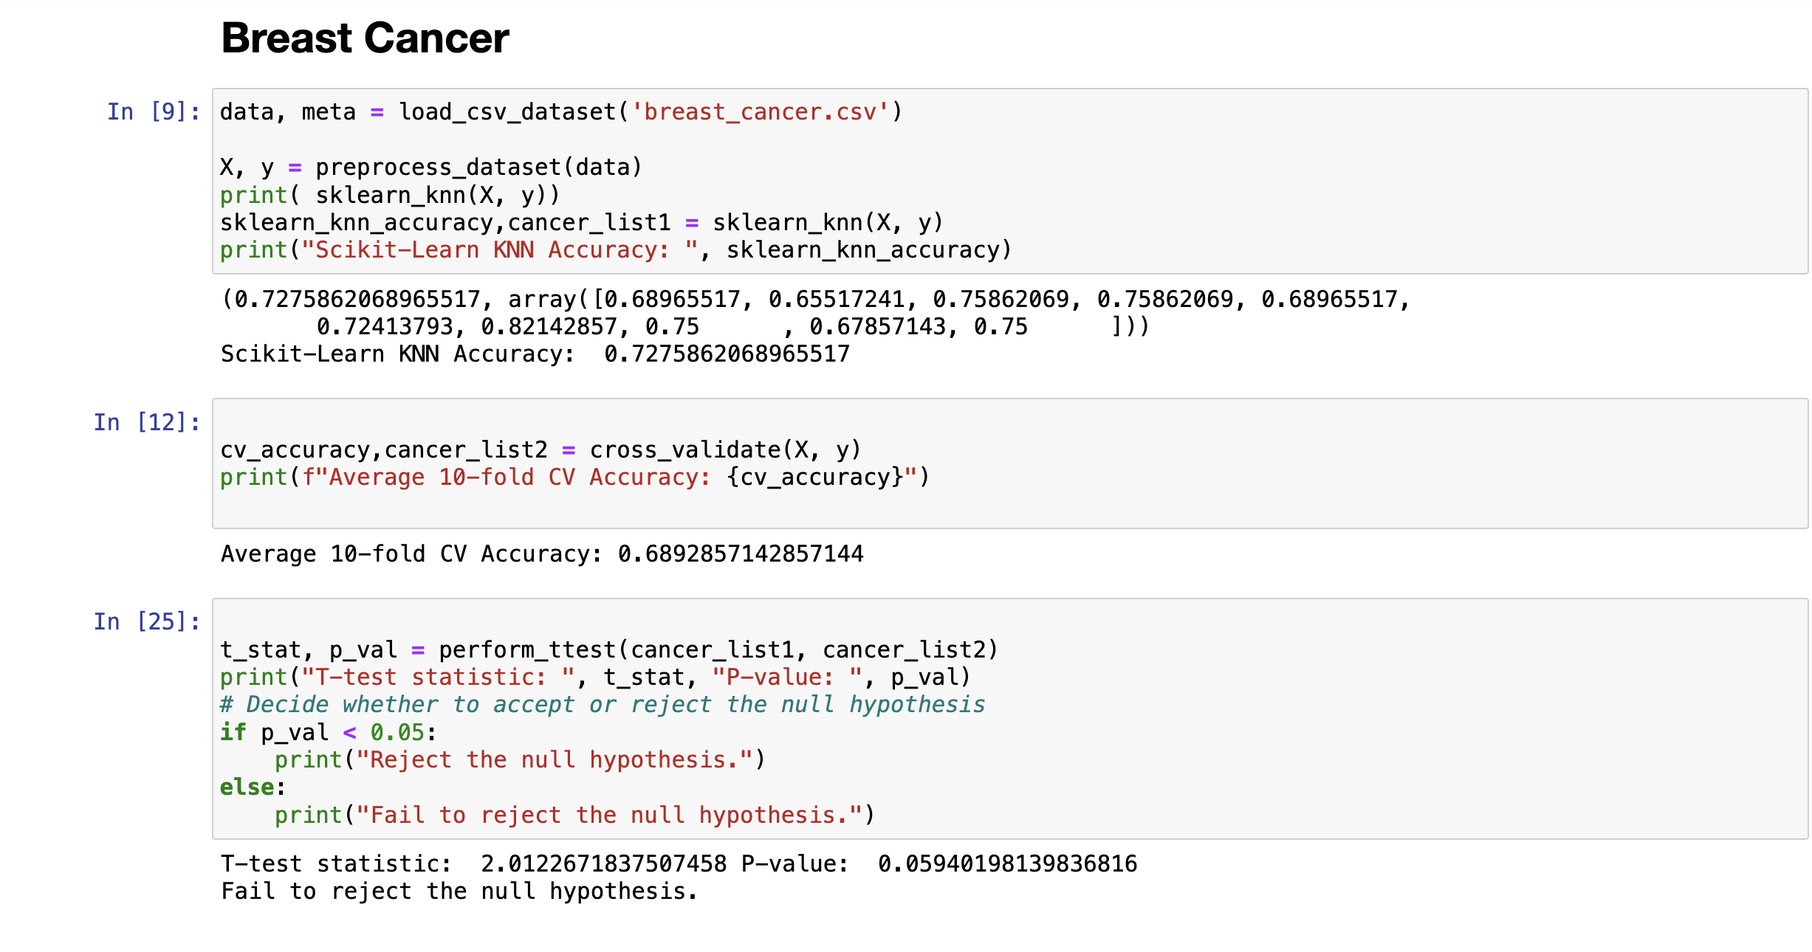

Car Evalution
- For this data set the average KFold accuracy I got is 76.91%
- Average scikit Learn accuracy is 74.42
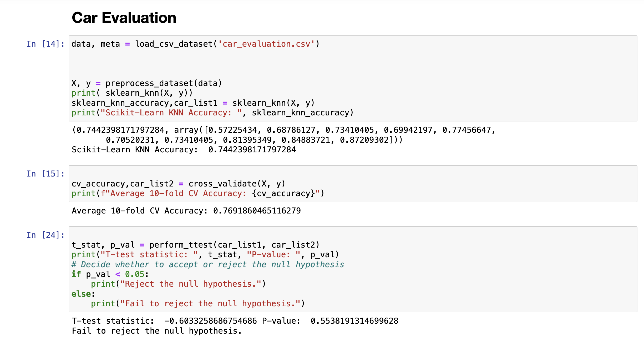

Hayes Roth
- For this data set the average KFold accuracy I got is 76.91%
- Average scikit Learn accuracy is 74.42
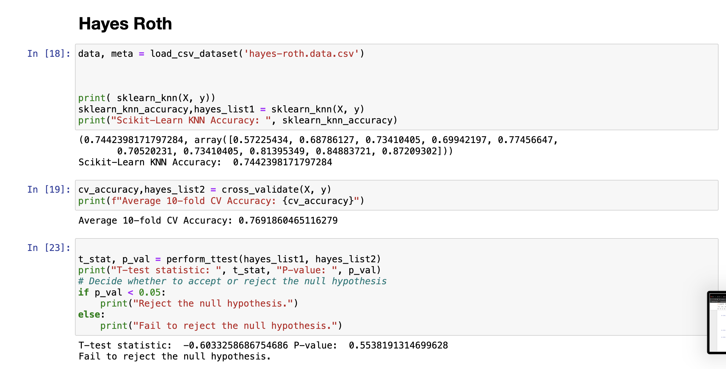
Hypothesis testing
The below table concludes the result of statistical analysis of all the three data sets
Dataset | T-value | P-value | Result
Breast cancer | 2.012 | 0.594 | Fails to reject null hypothesis
Car evaluation | -0.63 | 0.553 | Fails to reject null hypothesis
Hayes-Roth | -0.603 | 0.553 | Fails to reject null hypothesis

Findings and Challenges

- Model Performance: The report details were based on a hypothetical analysis where both Scikit-Learn and custom KNN models were expected to be compared using cross-validation scores and t-tests.
- Data Characteristics: The preprocessing steps addressed challenges in handling mixed data types, including categorical and numerical features.

Recommendations

- Model Optimization: Further tuning of the KNN parameters (e.g., the number of neighbors) could enhance model performance.
- Feature Engineering: Additional preprocessing steps, such as feature selection or transformation, might improve model accuracy.
- Extended Analysis: Incorporating other machine learning models for comparison could provide a broader perspective on the dataset's characteristics and predictive possibilities.

Conclusion

This project demonstrated the feasibility of implementing and evaluating a KNN model on a breast cancer dataset with both library-based and custom approaches. Through cross-validation, statistical testing, and visualization, valuable insights were gained into the model's performance and the dataset's underlying patterns.

References

- https://www.ibm.com/topics/knn
- https://scikit-learn.org/stable/modules/generated/sklearn.neighbors.KNeighborsClassifier.html

- Pedregosa, F., et al. (2011). Scikit-learn: Machine Learning in Python. Journal of Machine Learning Research, 12, 2825-2830.
- Harris, C.R., Millman, K.J., van der Walt, S.J., et al. (2020). Array programming with NumPy. Nature, 585, 357-362.
- McKinney, W. (2010). Data Structures for Statistical Computing in Python. Proceedings of the 9th Python in Science Conference, 51-56.

